Platform instructions

一、APP

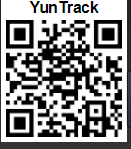

One：screen above QR code to download the APP；

Two：Serching “Yuntrack” at APP store or google play store to download APP.

APP Login：

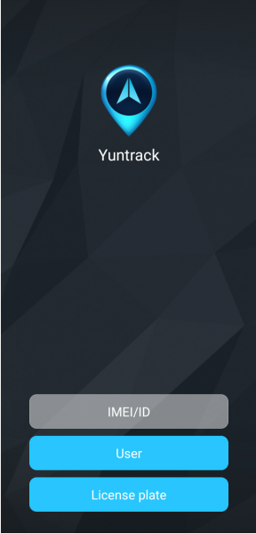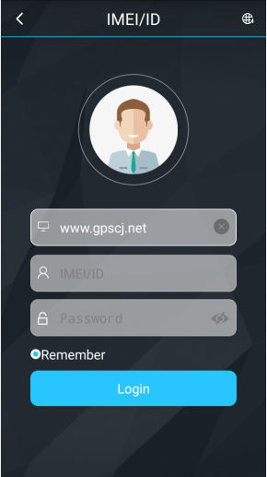

Website login

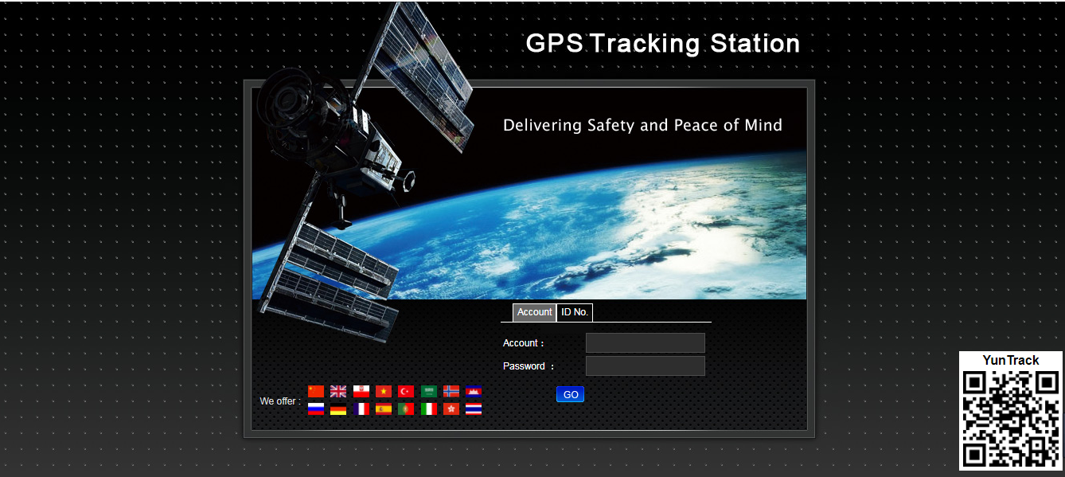

**Open the website www.gpscj.net, choose ID, enter the 10-digit bar code of the device, the default password is 123456, click “GO” to log in into the platform**